Module 2: Critical Thinking

Bryan Moffett
Colorado State University Global
ITS410: Database Management
Dr. Raquel Hicks
August 30th, 2026

Module 2: Critical Thinking
Task 1.3 - SELECT Statement to Retrieve Product Details
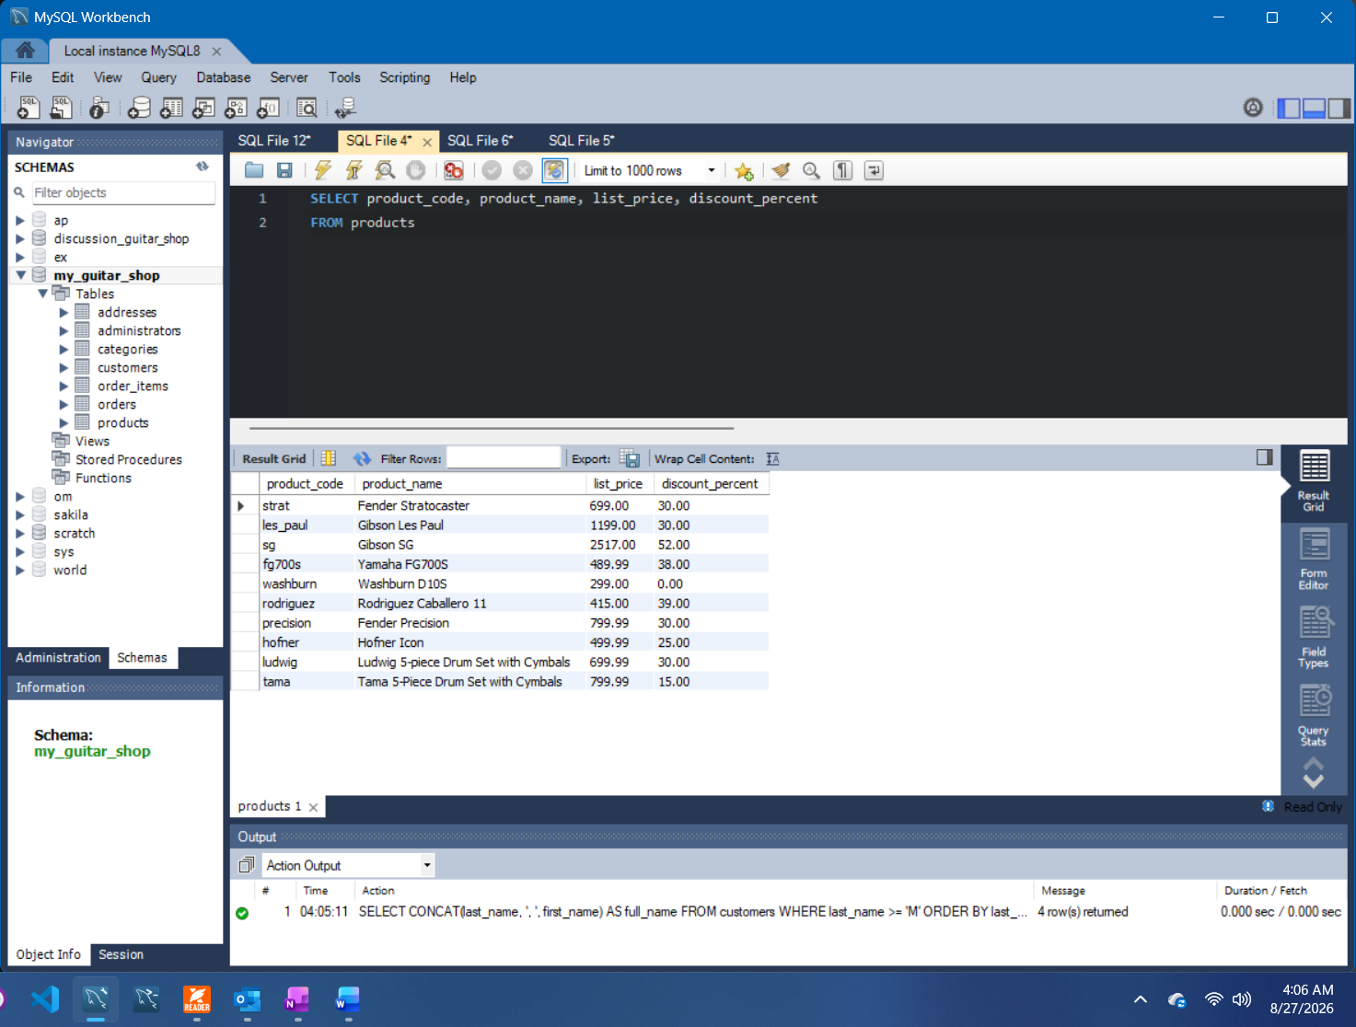

Task 2.4 - SELECT Statement to Retrieve Full Customer Names
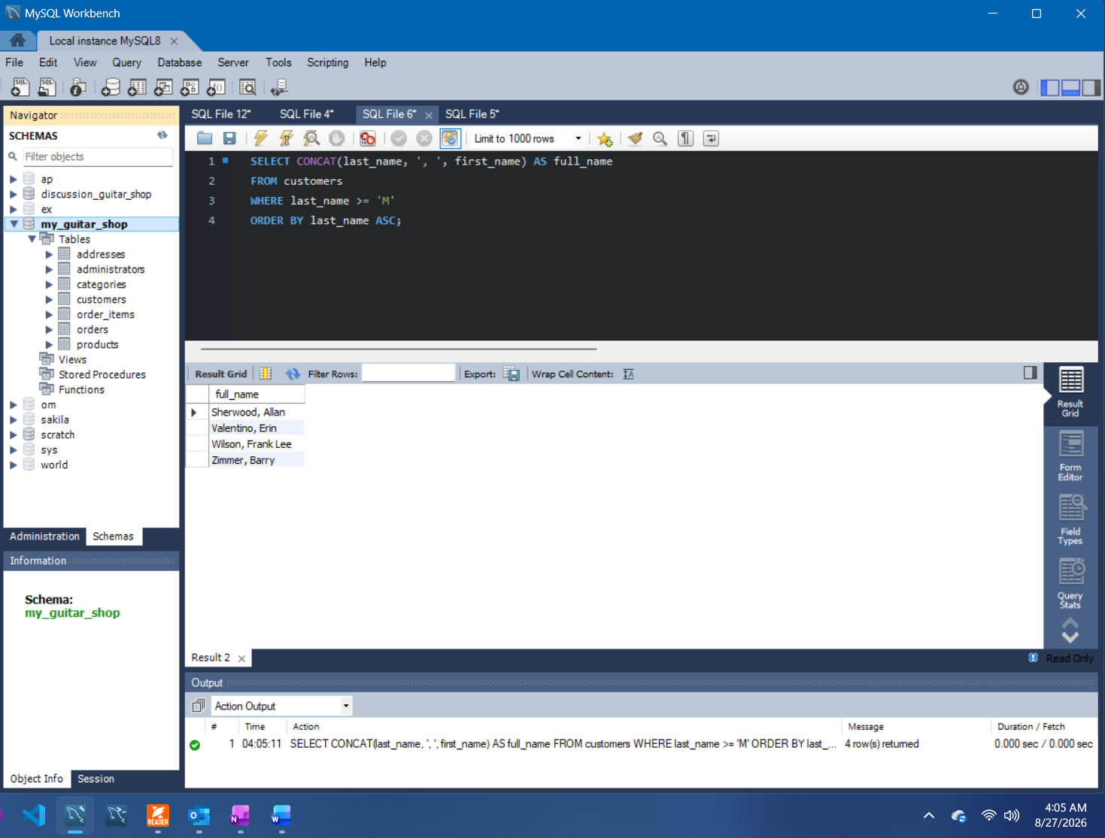

Task 3.4 - SELECT Statement to Return Products by Price and Sort by Date
